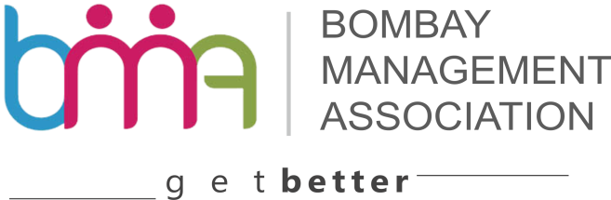
Outstanding Management Institute
Name of the Institute: _______________________________________________________________
Category : | Govt - |  |  | Private-

- Category 1 Top 25 B schools in Mumbai/ Navi Mumbai region/Thane

- Category 2 26-50 B school in Mumbai/ Navi Mumbai region/Thane

- Category 3 51-100 B school in Mumbai/ Navi Mumbai region/Thane

- Ranking for Tier 1, 2, and 3 will be based on rating by : -
- National Institutional Ranking Framework (NIRF)
or
- National Board of Accreditation (NBA)
or
- National Assessment and Accreditation (NAAC)
or
- Other Recognised National Agencies

Address and Contact details: __________________________________________________________
____________________________________________________________________________________________________________________________________________________________________
Courses held:______________________________________________________________________

P1. Curriculum
  - State the name and number of the value added courses conducted by the institute beyond the curriculum:
- No. of Courses
- Names of the Courses

  - State the number of students enrolled in each course?

Name of the Course | No of students enrolled

P2.Physical infrastructure

- Classes Labs
- Library
- Conference /Seminar area,
- Campus size in acres.

P3. Faculty

- Academic qualification of faculty (highest degree)

P4. Commitment towards professional development of faculty

- Faculty development,
- faculty grants,
- faculty exchange programs

P5. External orientation
- No of international linkage,
- Collaborative projects,
- Faculty on company boards and government bodies,
- Institute board of studies

P6. Research publication of faculty

1.
2.
3.
4.
5.

P7. Placement record of previous year

P8. Steps taken to enhance the Industry – Academia Interaction

________
Director Office Stamp

Date _________
Place__________

