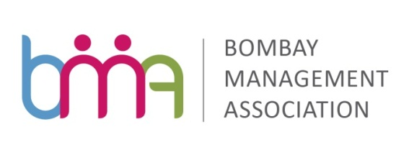

Inviting Participants for 2 day workshop on “Decision Making Simplified”
As part of
Newly Launched “Smart Manager Series”
Date: 16th & 17th November, 2017 (Thursday & Friday) Time: 9.30 am to 5.30 pm
Venue: BMA Knowledge Enrichment Facility, 9, Podar House, A Road, Churchgate – 400020

SMART MANAGER SERIES
Scope

The Smart Manager Series of training programs launched by Bombay Management Association is aimed at providing a comprehensive training support to mid-level managers who are tomorrow’s leaders. The modules are specially designed with concepts from Harvard Business Review, McKinsey and other leading publications bringing to the table deeper insight and values.

Option 1 is a basket of eight Modules of 2 days each:-  1. Mastering the Art of Communication  2. Managing Self for Success  3. People Leadership  4. Collaborative Teaming  5. The Next Level Leadership  6. Managing Change  7. Strategy & Execution  8. Decision Making Simplified | Option 2 is a set of 2 modules of 4 days each:  Module 1 (4 days) – titled ‘The Effective Manager’ Module 2 (4 days) titled ‘Leadership - Simplified for  Managers’  This two set module has been designed to give a good exposure in one go to senior managers aspiring to become successful in their leadership pursuits and assignments.
OPTION 1
MODULE NO.8 - DECISION MAKING SIMPLIFIED
Aim

Problems are part of work life. Dealing with problems and decision making is crucial to the success of a leader as well as the organization. The program aims at helping managers to understand various approaches to Decision Making. Participants will learn about problem solving techniques that will help to improve their decision making skills and re-orient them towards taking calculated risk.

Learning Objectives

In this program, participants will learn:

1. To evaluate risks before taking decisions
2. To check out cause and effect of reasoning
3. To take bold decisions by challenging the present format
4. To support decisions with authentic data
5. To check decisions through pilot projects
6. To support new entrants into managerial roles
7. To overcome indecisiveness
8. To be able to accept criticism in a positive way

Pedagogy

Interactive learning sessions with a mix of personal explorations, concept sessions as well as group activities.

Who should attend?

All professionals who want to learn how to be more decisive.

Facilitator

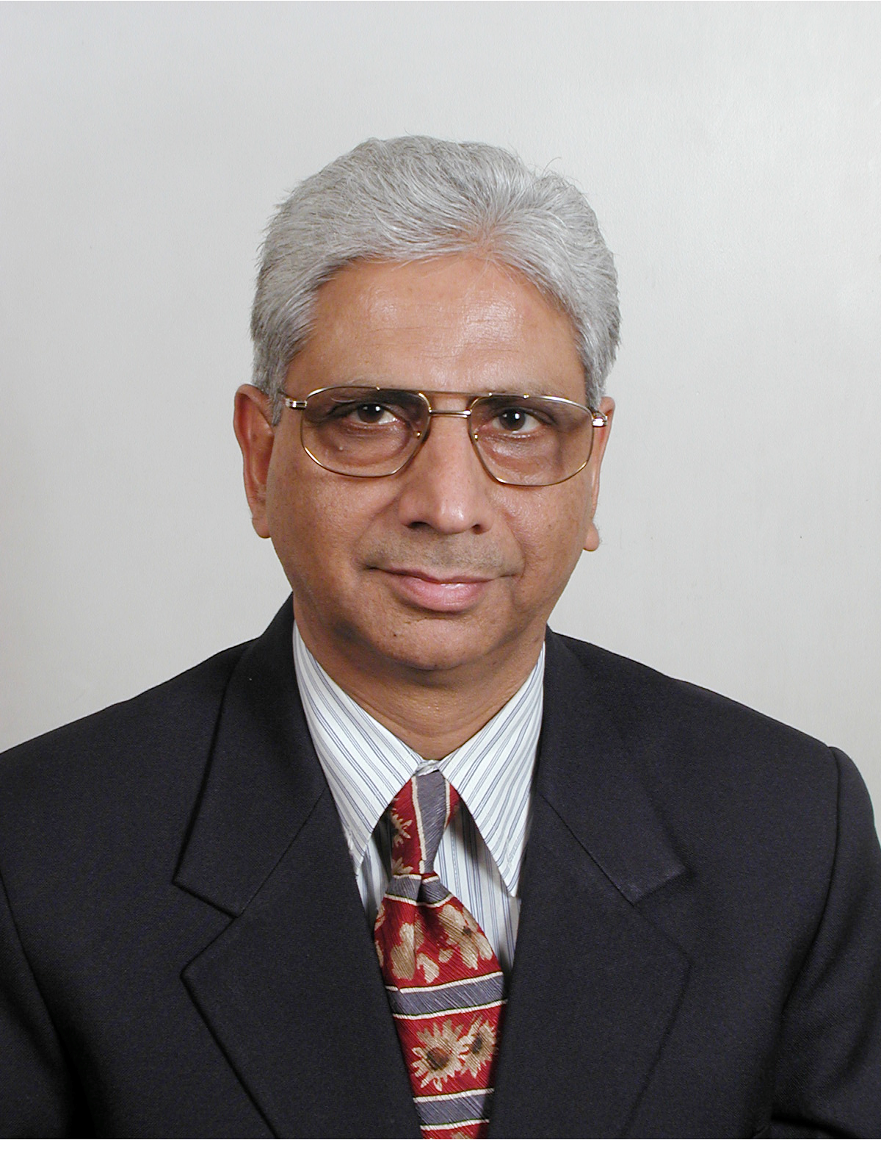
Mr. Gopal Sehajpal Gopal is an Associate Certified Coach (ACC) with the International Coach Federation (ICF) with more than 700 hours of coaching to his credit. In addition to this he is also a Certified Marshall Goldsmith Stakeholders Centered Coach. Gopal has spent many years providing unique cultural and leadership insights that help multinational clients achieve new levels of productivity and performance. Currently, Gopal has passion to transform business and industry leaders into highly effective corporate stewards. He found that when they work at their brain-level, and improve their thinking, they have always produced stupendous results. Gopal therefore finds that coaching approach derived from the neuroscience has the best application to realize his mission. He believes in contribution and commitment and coaches’ leaders to enjoy these rather than considering it mundane and burden. Adherence to ICF competencies ensuring results-focused growth, neuroscience is his most trusted tool. Gopal has worked with ICF accredited, brain-based NeuroLeadership Group: as a Lead Trainer, Executive Coach and an Assessor and has assessed executives in high performance coaching skills most of the MNC and top Indian Companies like: Deutsche Bank, Bayer, Times of India, Engineers India, Life Insurance Corporation of India, to name a few. Gopal has effectively lead Coach Training and Performance Leadership Programs in South Asia. Gopal started his career with KODAK. During this entire tenure of work experience with KODAK, he had exposure to cross-functional responsibilities and was highly qualified for Profit Centre Management. Gopal also has a lot of international exposure. He was trained in the USA (Rochester, NY) Singapore, Bangkok & Dubai operations of Kodak.

Registration Fees

Fee Structure: Rs. 10000/- Per Module (2Days) +18 % GST Tax
- Early Bird – 5% Discount
- 10% Discount for more than 1 participant
- 15% Discount for Members
Cheque / DD in favour of ‘Bombay Management Association

For more details, contact:

Colonel A R Khadar on: M: +91 8939924315; T: 022-22029615(D) +91-22-22047650 / 9698(B) Email: khadar.ark@bma-india.com
Bombay Management Association, 9, Podar House, 3rd Floor, ‘A’ Road, Churchgate, Mumbai 400020 www.bma-india.com

Note: During each program, there would be an experience sharing by an eminent speaker from industry, public & Armed Forces who are experts in their respective fields.

