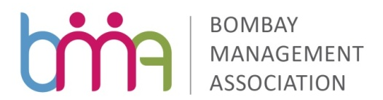
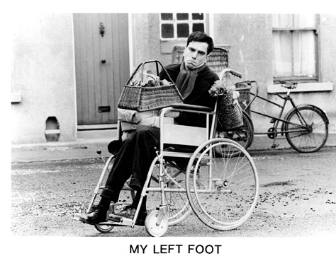
Inspiring Movie of the Month

“My Left Foot”

What the Movie Covers:

Daniel Day-Lewis and Brenda Fricker give Oscar winning performances in an emotional tale of life, love and one family’s incredible sense of courage.
Based on the story of Christy Brown, this highly acclaimed film depicts his struggle for a normal life. Born with cerebral palsy into a poor, working-class Irish family, Christy was able only to control movement in his left foot and to speak in guttural sounds. With the help of this strong-willed and dedicated family and his own sheer courage and determination, Christy not only learns to grapple with life’s simple physical tasks and complex psychological plains, but he also develops into a brilliant painter, poet and author.

Take Away:

Whatever mind conceives and believe, it can achieve. It is all about self belief, and not giving up in spite of all hurdles. In a long term persistence pays.

Date: 18th June, 2015 (Thursday)
Time: 6:00 to 8.00 pm
Venue: Bombay Management Association,
9, Podar House, 3rd Floor, “A” Road, Churchgate, Mumbai 400 020

400020
Mr. Bhaskar Joshi
Chairperson

Free Registration
For Enquiry / Registration contact
Shirley - shirley@bma-india.com
Phone: +9122-22047650/ +9122-22049698
9, Podar House, 3rd Floor,“A” Road, Churchgate, Mumbai 400 020
Website:www.bma-india.com

