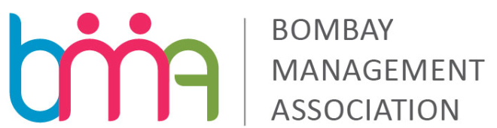
WORKSHOP ON HR ANALYTICS
On 29th April, 2015

Registration Form
 | Member 1 | Member 2 | Member 3
Name
Designation
Tel No.
Mobile No.
Email

Organization Name & Address ____________________________________________________________________

Name of Contact Person ________________________________ Contact Number:__________________________

Fee (per person) including Service tax 12.36% |  | Specify Category (put a tick)
3,200/- |  | BMA member
4,500/- |  | Non BMA member
Mode of Payment: By Cheque/Demand Draft OR Net Banking.

Cheque/DraftNo_____________________________________ Dated _______________Drawn on ___________________
(Name of the bank) In favour of “Bombay Management Association” for Rs.____________ is enclosed along with the registration form to be couriered to

Mrs. Mayuri Mistry
Director,
Bombay Management Association,
9, Podar House, 3rd Floor, ‘A’ Road,
Churchgate, Mumbai 400 020.
Tel.: 2204 7650 / 2204 9698 l Fax: 2202 4743

Through Net Banking Amount to be transferred to: Kotak Mahindra Bank
Bank A/c No. - S/A No. 06370010003480 MICR Code: 400485008 NEFT IFSC Code: KKBK0000637.

Transferor Bank Name: |  |  | Amount
Transaction Reference No. |  |  | Date of transaction
Please mail the scanned copy of the registration form duly filled in to: shirley@bma-india.com
*Participation will be confirmed subject to receipt of participation fee. The participation fees are non-refundable, however, participation by a substitute shall be allowed.

________________________
Authorised Signatory

